**SOURCE CODE**

**CAPSTONE PROJECT : FOOD BOX**

**BY PRATULYA TIWARY**

Contents.

1. User Flow Chart Diagram 3
2. GitHub Link… 4
3. Database Design… 4
4. Folder Structure… 6
5. Project Files… 11

# User Flow Chart Diagram.

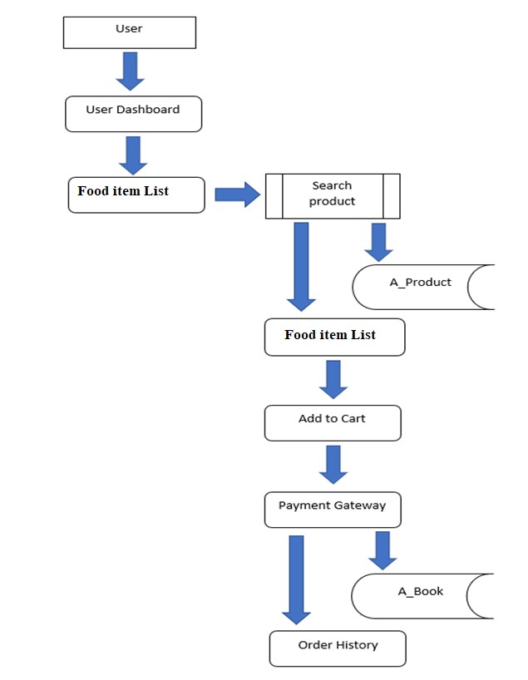

1. ***GitHub Link.***

|  |  |
| --- | --- |
| **Repository Name.** | FoodBox-Capstone-Project |
| **GitHub Link.** | https://github.com/codorhythm/capstone |

1. ***Database Design.***

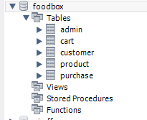

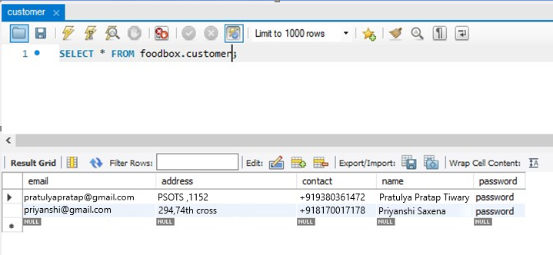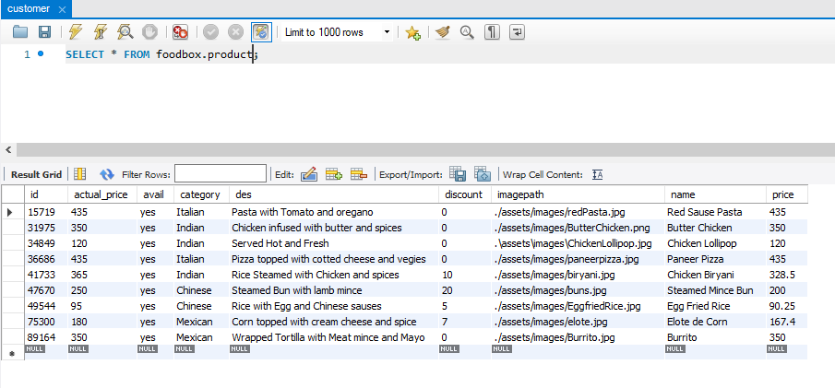Data Result Set:

1. ***Folder Structure.***

**(Back End Development)**

Spring Project Structure

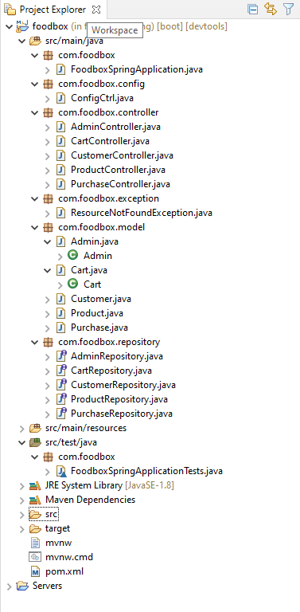

Pom.xml

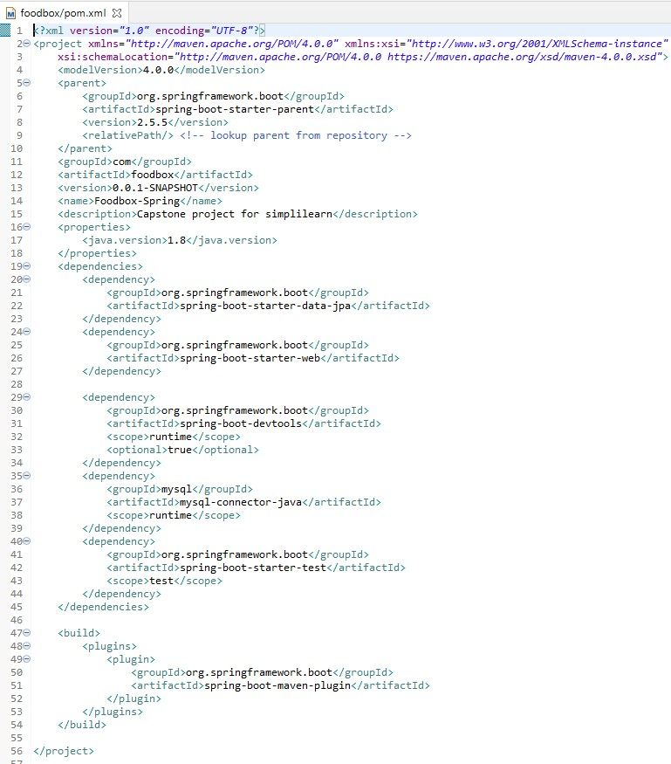

FoodSpringApplication.Java

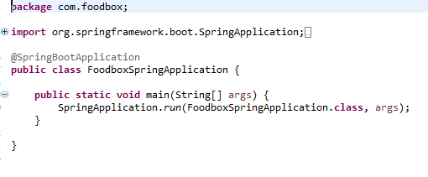

FoodboxSpringApplicationTests.Java

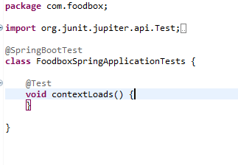

Rest of the files are present in the given GitHub link kindly refer this…

git@github.com:codorhythm/capstone.git

Spring Output:

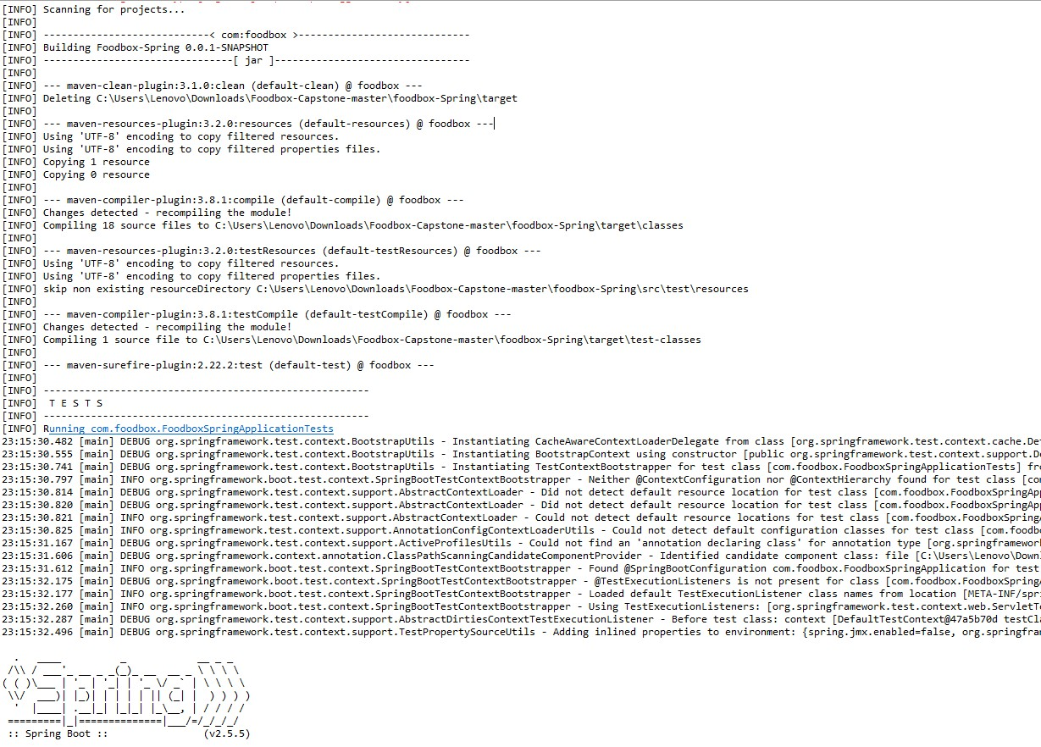

**(Front End Development)**

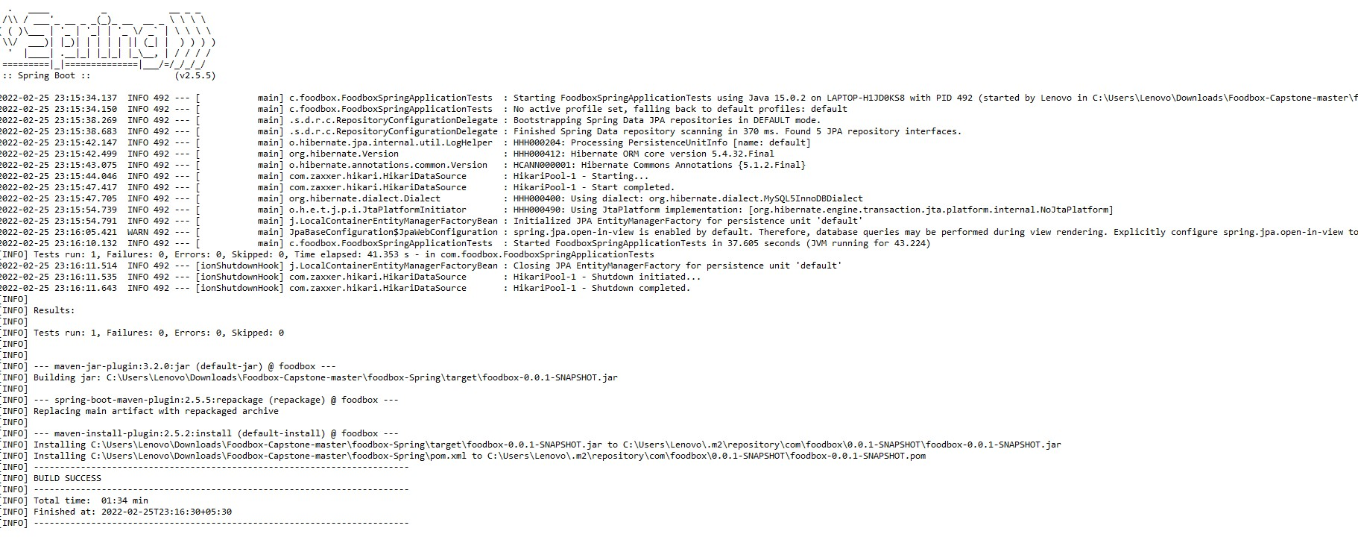

Angular Project Structure:

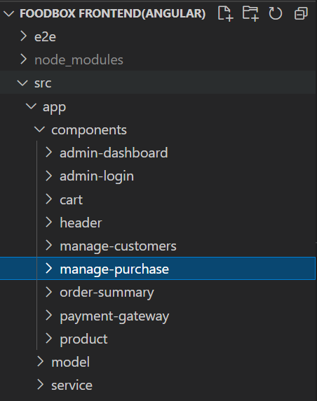

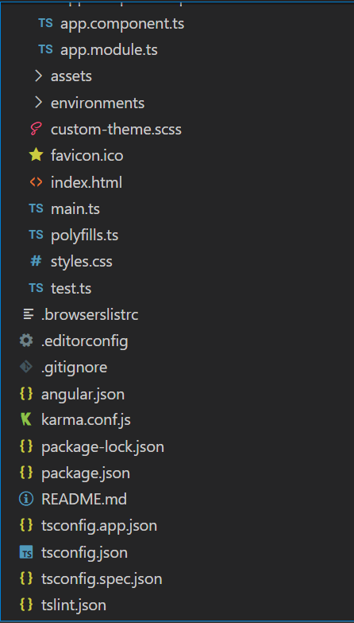

1. ***Project Files.***

Index.html

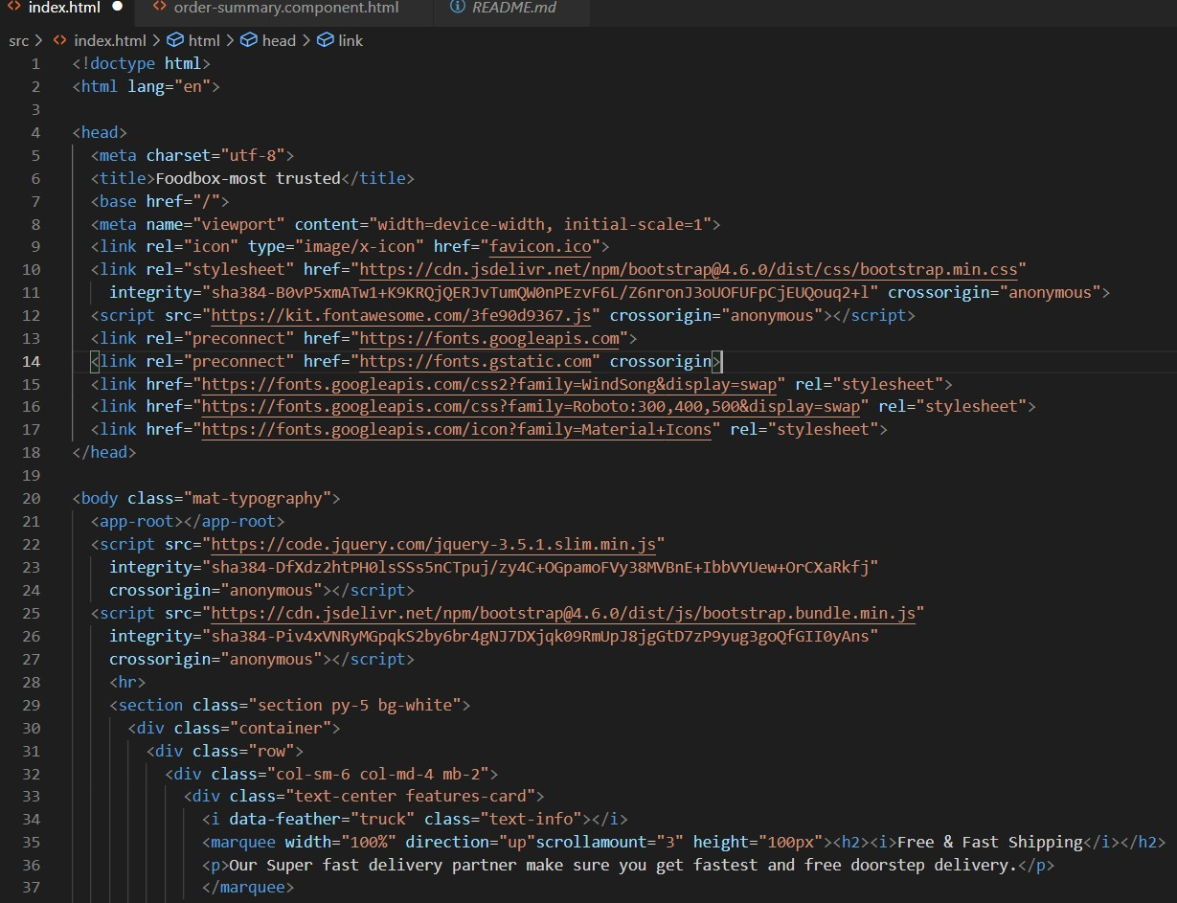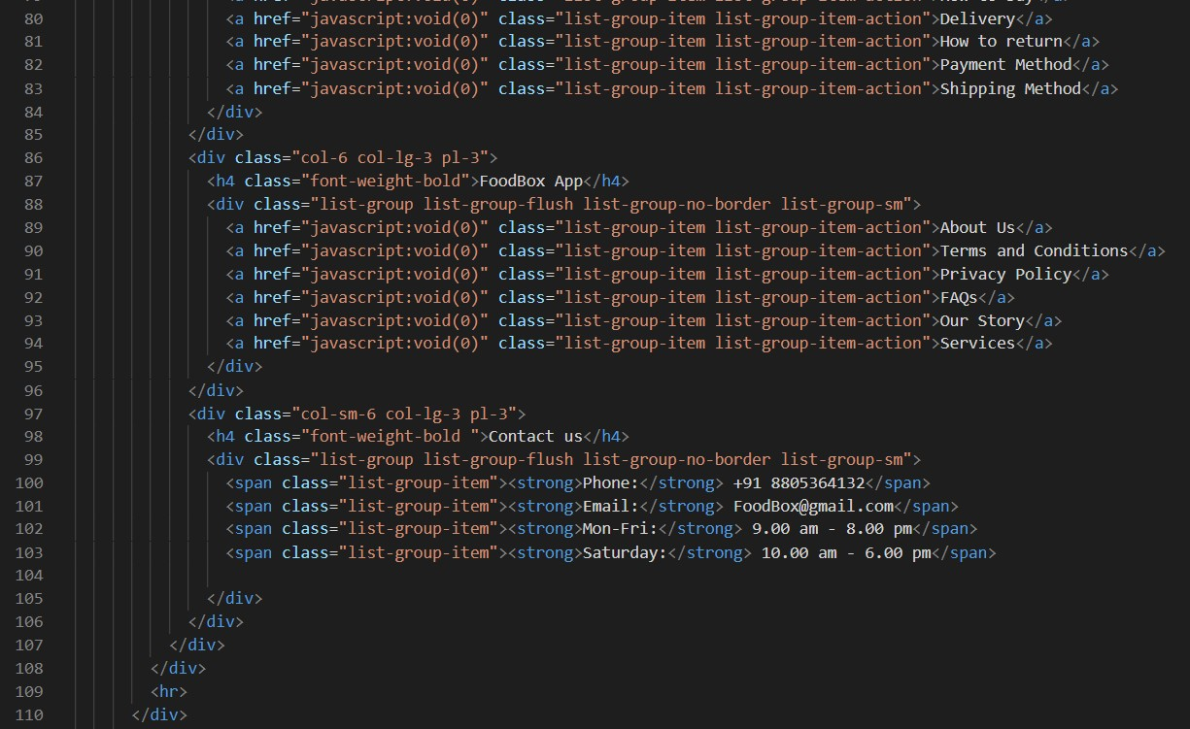

test.ts:

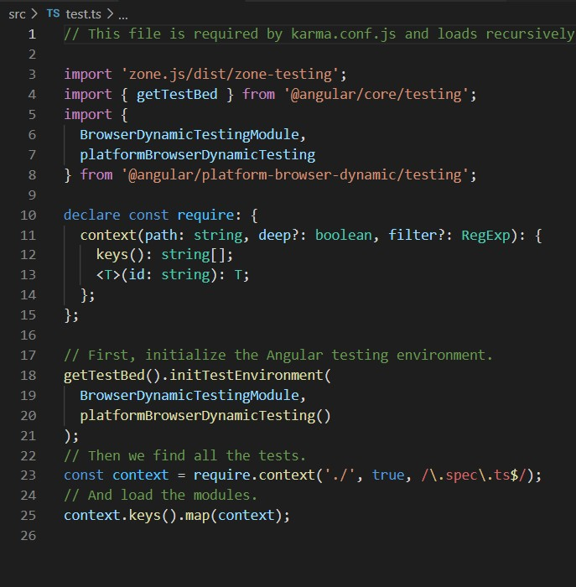

Rest of the files are present in the given GitHub link kindly refer this…

git@github.com:codorhythm/capstone.git

## Package.json:

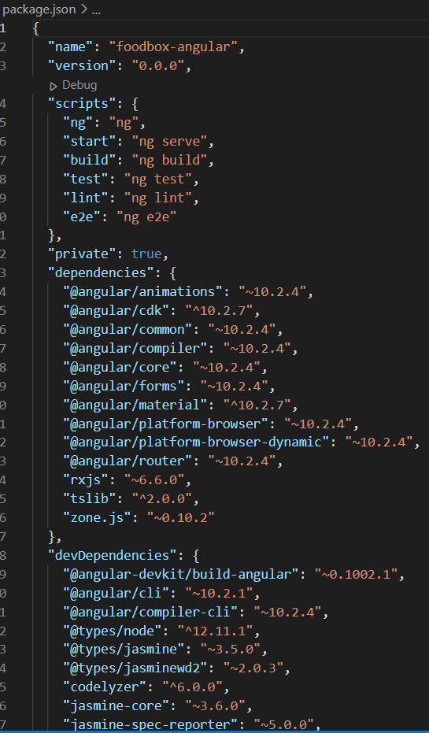

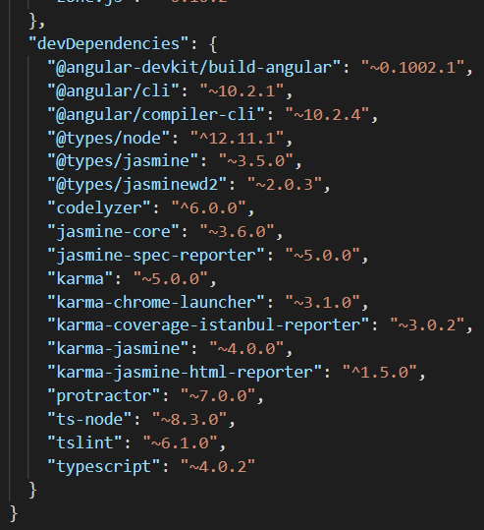

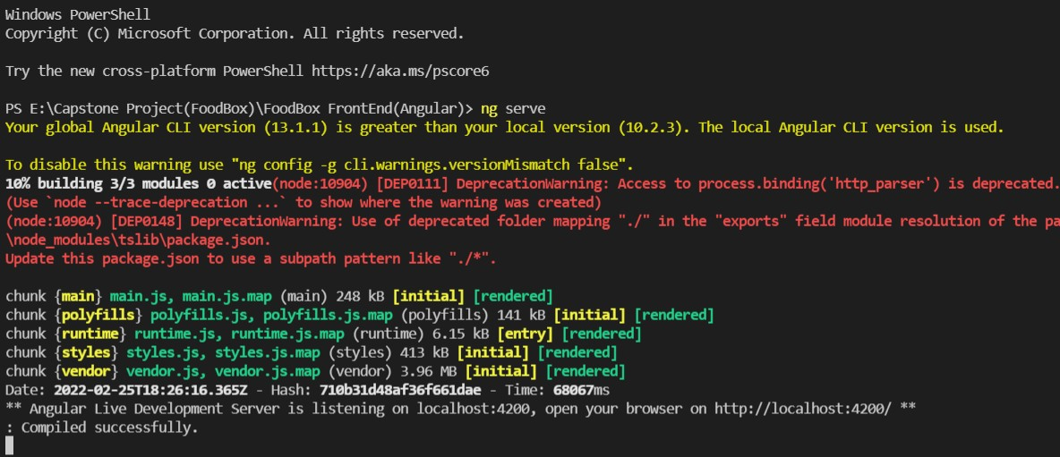Angular Outputs:

THANK YOU……………